Horizon 65mm Multi-Tool Compatible with AFC-746AKT Machine
Adapter Collar and Cutting Boss Assembly Installation Guide
Please read through these instructions completely before attempting installation.

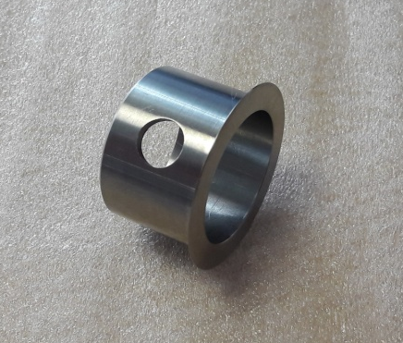
You will receive 2x Adapter Collars as part of your Multi-Tool Complete Pack.
Product Code: COLLAR-AD/29.8-35
This part is supplied to enable the Cutting Bosses to fit onto a 30mm diameter shaft.
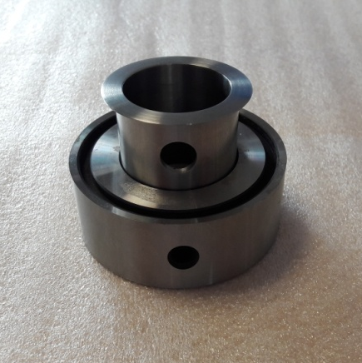
Before fitting into the folding machine, insert the Adapter Collar into the supplied Cutting Boss as shown.
Be sure to align the hole in the Adapter Collar with the fixing screw position in the Cutting Boss.
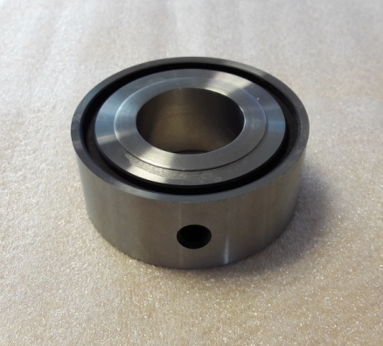
When inserted, the Adapter Collars will sit flush to the edge of each Cutting Boss as shown.

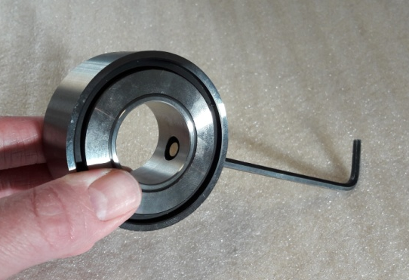
Using a 4mm Allen Key wind the fixing screw so that the brass tip sits inside of the hole positioned in the Adapter Collar.
The Adapter Collar is now attached to the Cutting Boss. The fitting will be loose but the Adapter Collar should not be able to be separated from the Cutting Boss at this point.
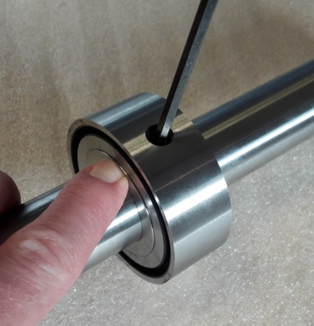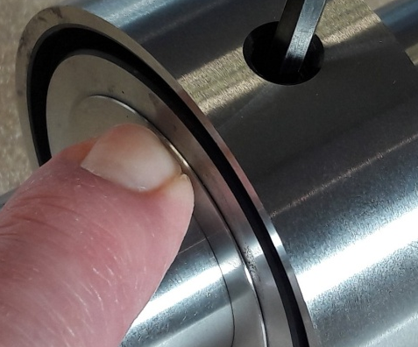
Slide the Adapter Collar and Cutting Boss assembly on to your shaft and position as required.
When tightening the fixing screw make sure the Adapter Collar wall is pushed flush against the face of the Cutting Boss as shown.
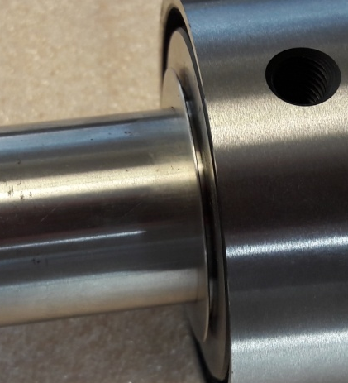

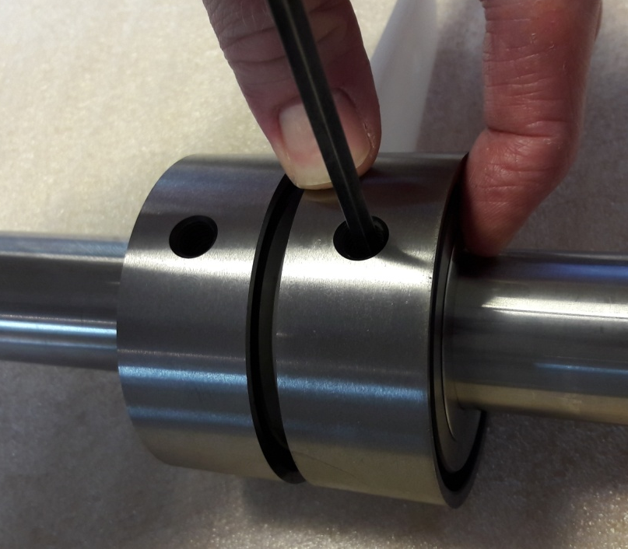
For Gulley Cutting or Centre-Trimming Applications
When setting up applications that require the use of both Cutting Boss units with the Waste Stripper Removal Guide, it is advised that the Adapter Collar and Cutting Boss assemblies are installed with the Adapter Collar wall facing outward and away from the centre Waste Stripper Removal Guide.
This will ensure that the gulley cutting or centre trimming widths are not reduced.
At all times, avoid installing the Adapter Collar and Cutting Boss assembly with a space between the Adapter Collar wall and the face of the Cutting Boss (example shown).
Doing so might result in reduce cutting capabilities.

Waste Stripper Removal Guide

Adapter Collar Wall Facing Outward

Adapter Collar Wall Facing Outward

